|  |  |
| --- | --- |
| **TEAM ID** | **PNT2022TMID36960** |

**YOLO V3:**

**YOLOv3 Object detection:**

YOLOv3 (You Only Look Once, Version 3) is **a real-time object detectionalgorithmthatidentifies specific objects in videos, live feeds, or images**. The YOLOmachinelearningalgorithm uses features learned by a deep convolution neural network to detect an object.**YOLOv3isthemost recent variation of the You Only Look Once (YOLO) approaches**. This familyof modelsis popular for real-time object detection which in 2015 was introduced in the paper “You OnlyLookOnce:Unified, Real-Time Object Detection” by Joseph Redmon et al.

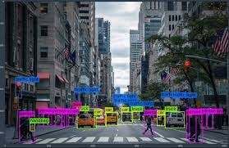

**YOLO model in a windows environment:**

Create ***yolov3*** and ***training*** folders on your Desktop Open a command prompt and navigate to the “**yolov3**” folder Create and copy the **darknet.exe**

file

Create & copy the files we need for training ( i.e. “**obj**” dataset, “**yolov3- custom.cfg**”,

“**obj.data**”, “**obj.names**” and “**process.py**” ) to your ***yolov3***dir

Copy the “**yolov3-custom.cfg**”, “**obj.data**”, “**obj.names**”, and “**process.py**”filesand the **“obj”** folder from the ***yolov3*** directory to the ***darknet*** directory

Run the **process.py** python script to create the **train.txt** &**test.txt** files Download the pre-trained **YOLOv3** weights

Train the detector

Check performance

Test your custom Object Detector

**Flask:**

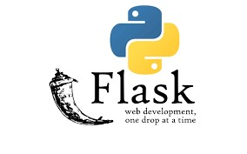

**Introduction to Flask:**

Flask is a web application framework written in python It is developed by Armin Ronacher, who leads an international group of Python enthusiasts named Pocco. Flask is based on the WerkzeugWSGItoolkit and Jinja2 template engine. Both are Pocco projects.

**Installing & Working with Flask:**

Install Flask

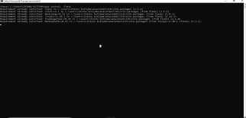

Virtual python Environmental Builder

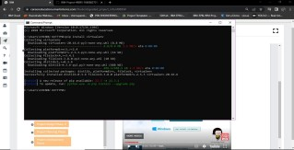

**Overview of Flask:**

Flask is a web application framework written in Python. It is developed by Armin Ronacher, who leads an international group of Python enthusiasts named Pocco. Flask is based on the WerkzeugWSGItoolkit and Jinja2 template engine. Both are Pocco projects.

**WSGI**

Web Server Gateway Interface (WSGI) has been adopted as a standard for Python web application development. WSGI is a specification for a universal interface between the webserver and the web applications.

**Werkzeug**

It is a WSGI toolkit, which implements requests, response objects, and other utility functions.This enables building a web framework on top of it. The Flask framework uses Werkzeugas oneofits bases.

**Jinja2**

Jinja2 is a popular templating engine for Python. A web templating system combine template

with a certain data source to render dynamic web pages.

Flask is often referred to as a micro framework. It aims to keep the core of an application simple ye

textensible. Flask does not have built-in abstraction layer for database handling, nor does it have form avalidation support. Instead, Flask supports the extensions to add such functionality to the application. Someof the popular Flask extensions are discussed later in the tutorial.

**Practical approach:**

**Write simple code**

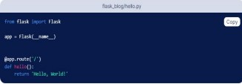

**Flask -HTML**

